using System;

using System.Collections.Generic;

using System.Linq;

using System.Text;

using System.Threading.Tasks;

using System.Windows;

using System.Windows.Controls;

using System.Windows.Data;

using System.Windows.Documents;

using System.Windows.Input;

using System.Windows.Media;

using System.Windows.Media.Imaging;

using System.Windows.Navigation;

using System.Windows.Shapes;

namespace WPFRegisterStudent

{

/// <summary>

/// Interaction logic for MainWindow.xaml

/// </summary>

public partial class MainWindow : Window

{

Course choice;

// Variable to keep track of course hours

int courseRegisteredHours;

public MainWindow()

{

InitializeComponent();

}

private void Window_Loaded(object sender, RoutedEventArgs e)

{

Course course1 = new Course("IT 145");

Course course2 = new Course("IT 200");

Course course3 = new Course("IT 201");

Course course4 = new Course("IT 270");

Course course5 = new Course("IT 315");

Course course6 = new Course("IT 328");

Course course7 = new Course("IT 330");

this.comboBox.Items.Add(course1);

this.comboBox.Items.Add(course2);

this.comboBox.Items.Add(course3);

this.comboBox.Items.Add(course4);

this.comboBox.Items.Add(course5);

this.comboBox.Items.Add(course6);

this.comboBox.Items.Add(course7);

this.textBox.Text = "";

this.label3.Content = "Richardson";

}

private void button_Click(object sender, RoutedEventArgs e)

{

choice = (Course)(this.comboBox.SelectedItem);

// Validate user selection has not been selected before

if (choice.IsRegisteredAlready())

{

this.label3.Content = "You have already registered for this course.";

return;

}

// Check total number of course hours

if (textBox.Text == "9")

{

this.label3.Content = "You cannot register for more than nine credit hours.";

return;

}

// Update the course's registration status

choice.SetToRegistered();

this.listBox.Items.Add(choice.getName());

this.label3.Content = $"You have successfully registered for {choice.getName()}.";

// Update the total credit hours textbox if registration is confirmed for a selected course

courseRegisteredHours += 3;

this.textBox.Text = $"{courseRegisteredHours}";

}

}

}

Showing both my last name as printed text and program’s main menu with course selection.

Displays a confirmation message for registration, adds to the list of currently registered courses and adds to the total number of credit hours.

An error message is given if a duplicate course has been attempted to be added.

Confirmation message is shown again for the course added. The total number of credit hours is also updated.

Again, a confirmation message is shown again for the course added and the total number of credit hours is also updated.

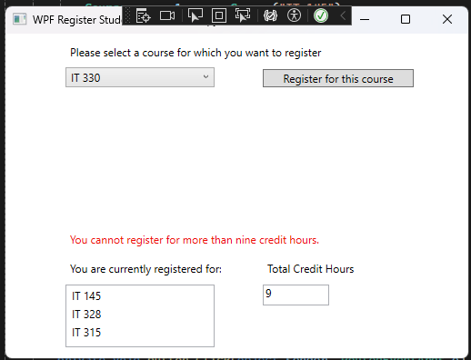

Attempting to add an course that puts the student over the total number of credit hours limit is given an error message.